**PROJECT PLANNING AND STRUCTURE:**

**All picture and background images used are Royality and copyright free taken from:**

[**https://unsplash.com/**](https://unsplash.com/)

[**https://www.pexels.com/**](https://www.pexels.com/)

Please use sign up links and forms first before using login form.

Repository: <https://github.com/Bre0409/JS_assign.git>

Git hub pages: <https://bre0409.github.io/JS_assign/>

**Idea and Concept:**

Design a website to introduce coding to beginners and younger generations making it exciting and fun by adding lots of colors, CSS graphical elements, interactivity and functionality using JavaScript.

**LAYOUT:**

Create one page with logo top left containing 4 sections with consistent nav bar with links to each section. A sidebar menu for mobile and tablet use. Page will contain graphical borders which will be removed in mobile and tablet devices.

**Sections:**

**Index/Home section:**

HTML/CSS:

This will consist of a background image styled header a paragraph introducing the concept of the website with a login form containing 2 input fields email and password with option to sign up, link to sign-up form a submit button when fields are correctly entered will re-direct you to computer coding page and styled social media icons below button.

JAVASCRIPT: see home.js

Navbar:

An onclick attribute to open and close sidebar as well as touch close or click away to close functionality on tablet and mobile.

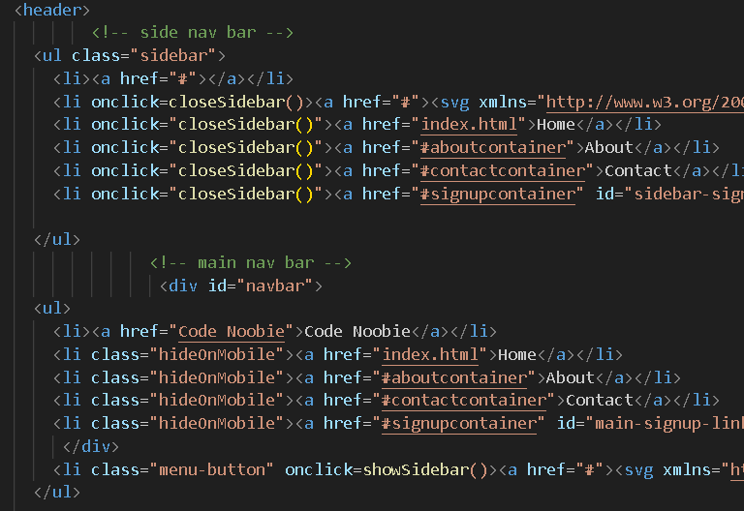

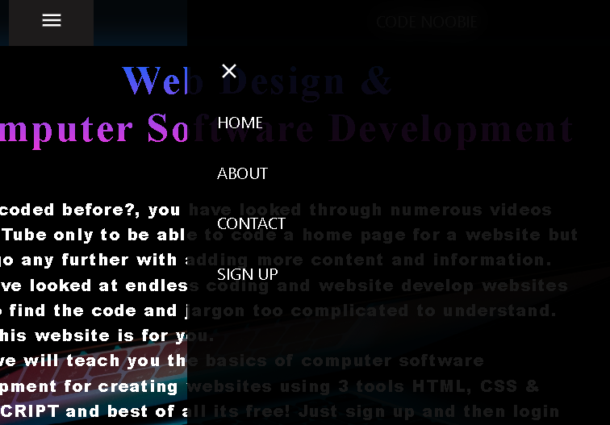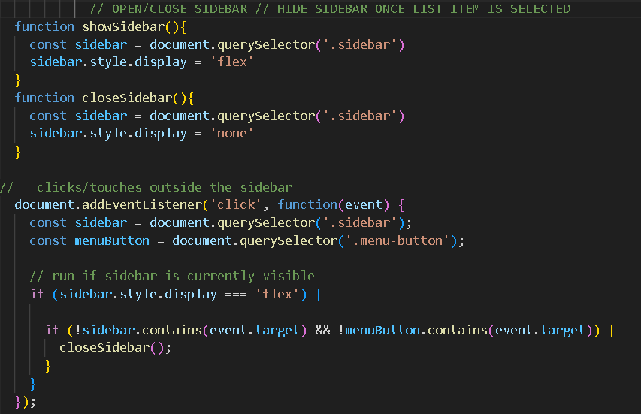

Validation for login form inputs, email must contain @ and . with text before and after@ symbol. Password must contain at least 8 characters. Errors will be displayed by JavaScript if criteria are not met. An onclick attribute when all conditions are met the login in button will transfer you to coding page after displaying success message.

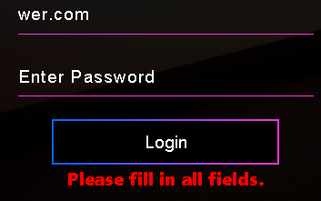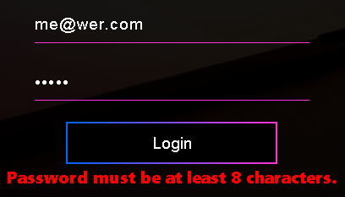



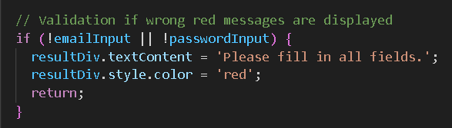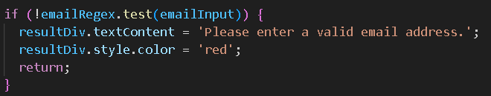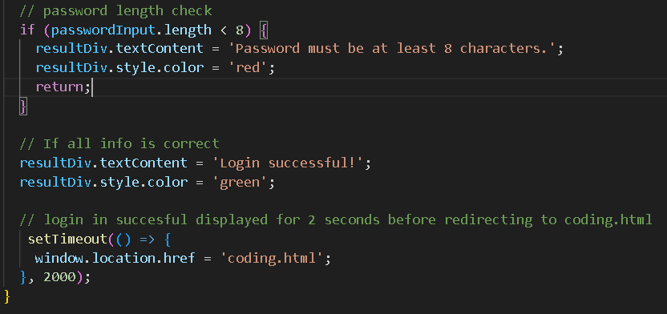

**About Us Section:**

HTML/CSS:

This will contain a background image a header followed by a paragraph about the creators, their experience and what they aim to achieve with the website followed by their pictures displayed below the paragraph.

JAVASCRIPT:

None

**Contact Us Section:**

HTML/CSS:

This will contain a background image a header and a query selector form where you will pick a query from a dropdown list with 2 input fields for name, email and a text area for comments with a submit button below and link to login form.

JAVASCRIPT: see contact.js

Validation for query form. Onclick event that when submit button is clicked form will only submit if all fields met criteria. If any or all fields are not correct JavaScript will display error messages styled by JavaScript. You must pick a query; name input field must be filled email must contain @ and . with text before and after@ symbol and text area/comment section must be filled. Success message will be displayed upon meeting correct criteria.

Query selector, event Listener, toggle event, for loop, event, if statement.

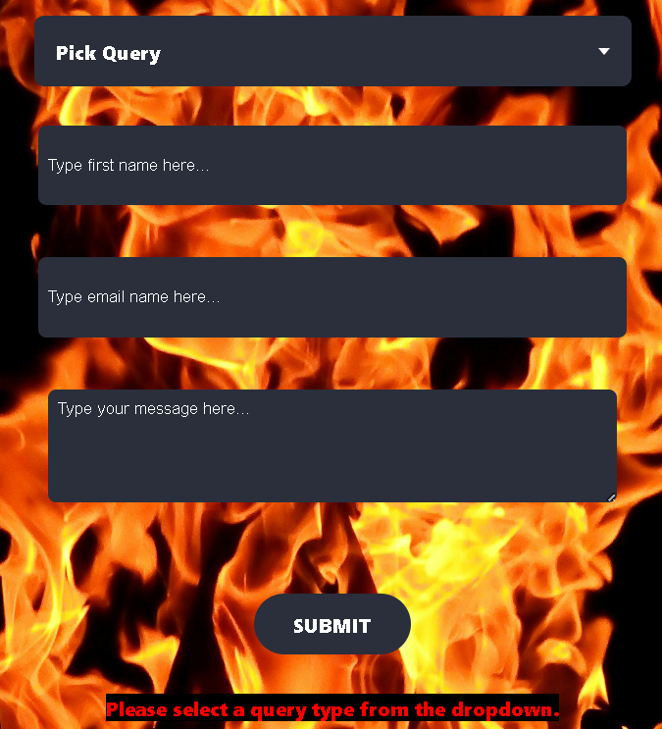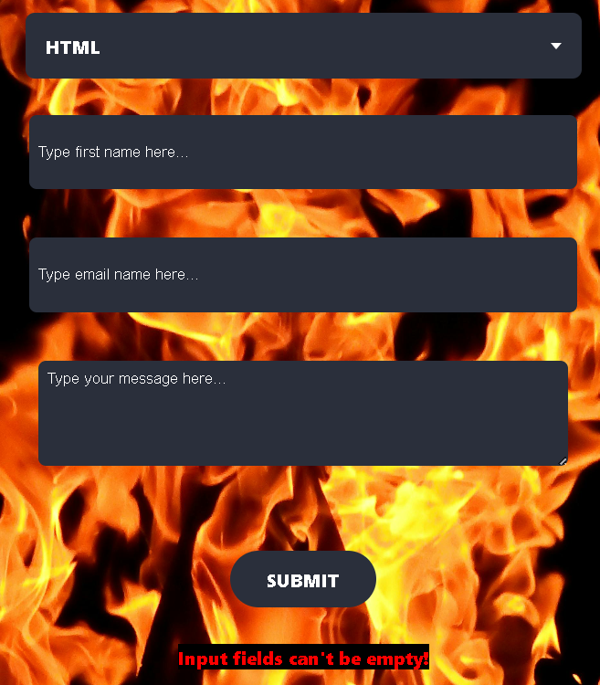

**Sign Up Section:**

HTML/CSS:

This will contain a background image a header and a sign-up form with 4 input fields for name, email, password and re-enter of password followed by a submit button. And color styling of buttons when errors occur.

JAVASCRIPT: see signup.js

Validation of sign-up form. Onclick event that when submit button is clicked form will only submit if all fields met criteria. If any or all fields are not correct JavaScript will display error messages styled by JavaScript and CSS. You must pick a query; name input field must be filled email must contain @ Success message will be displayed upon meeting correct criteria. Upon successful form completion the Sign up page will transform hiding input fields and displaying a login link and changing the nav bar sign-up link to Login form link in both navbar and sidebar.

Query selector, event Listener, for loop, event, if/else statement, push, add, join, appendChild(node).

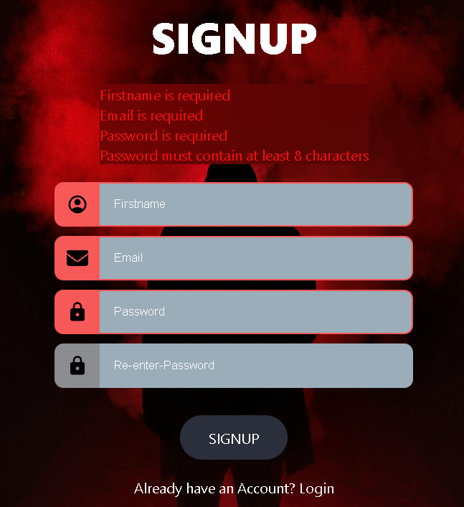  



Footer at the bottom with copyright and social media icons.

**Coding Page:**

This page is accessed only through successful login.

This page leads you into training exercises for HTML, CSS and JAVASCRIPT. For the sake of the Assignment and due to the massive scope of this potential website I have just created links to W3SCHOOLS.

HTML/CSS:

This page will contain a background animation and will consist of 2 buttons 1 for exiting and 1 for entering the next section of this page. Exit will return you to homepage. Upon selecting enter button 3 boxes will be displayed with content hidden and revealed on mouse hover with header having click functions redirecting to external link related to header name and a paragraph with brief description of header subject.

JAVASCRIPT: see coding.js

Onclick query selector when blue button is clicked buttons disappear, 3 boxes appear and white X appears in navbar for exiting. White X styled by JavaScript.

Event Listener, Onclick, querySelector.

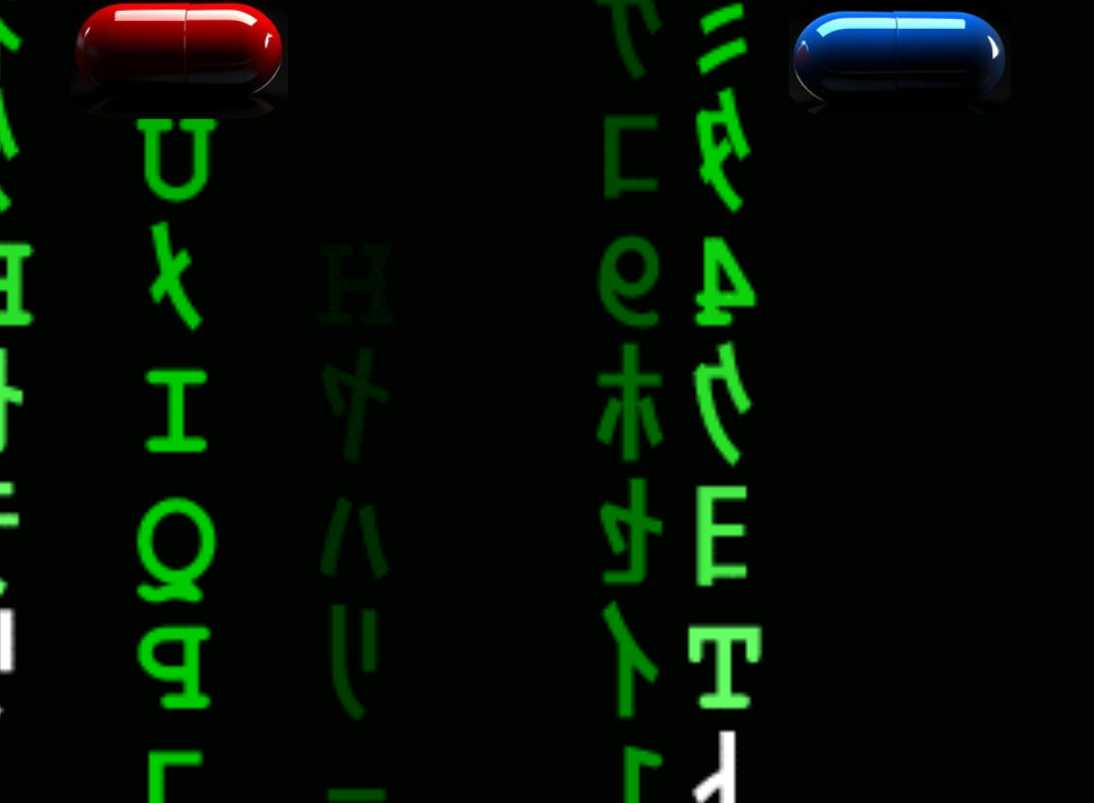   

**Challenges Faced:**

There are so many ways to implement something in JavaScript that I found myself approaching form validation lots of different ways and if I decided to change or add one thing it was easier to just start over as just adding another function could mean rewriting the entire code.

Also using HTML with CSS and then implementing JavaScript to achieve one particular outcome can become quite complicated with lots of back and forth deciding which language to use for each desired outcome for instance after a LOT of trail and error I found it much easier for example to create an empty div then add content style and give functionality with just JavaScript for say a paragraph. This is something I used to display error messages for form validation. Keeping everything in one place created better work flow and actually improved my JavaScript knowledge and implementation. I tried to be clever by Validating my 3 forms 3 different ways in JavaScript but found I only confused and limited myself and as a result in the end I found repeating code and using the same structures helped better the repetition allowed for better understanding of JavaScript and easier implementation. I have included some of the ideas in the JavaScript pages to show how I was thinking.